CPE301 – SPRING 2019

MIDTERM 1

Student Name: Mohamad Jundi

Student #: 8000321867

Student Email: jundi@unlv.nevada.edu

Primary Github address: https://github.com/MohamedJundi1994/Submission_Midterm1.git

Directory:

C:\Users\moham\Documents\School\CPE301\Repository\CPE_301\Midterms\Midterm 1

1. **COMPONENTS LIST AND CONNECTION BLOCK DIAGRAM w/ PINS**

LM34:

USB port => Xplained Mini => 5V => left leg (5V) LM34

=> PC5 => middle leg (output) LM34

=> GND => right leg (GND) LM34

ESP01:

USB port => Xplained Mini => 3V => Pin 1 (3V) ESP01

=> PD1 (Tx) => Pin 2 (Rx) ESP01

=> PD0 (Rx) => Pin7 (Tx) ESP01

=> GND => Pin8 (GND) ESP01

1. **INITIAL/MODIFIED/DEVELOPED CODE OF TASK 1/A**

#define *F_CPU* 16000000UL

#define BAUD 9600

#define NEWuussaarrtt *F_CPU*/16/BAUD-1

#include <avr/io.h>

#include <avr/interrupt.h>

#include <util/delay.h>

void initialization_usart( unsigned int uussaarrtt ); // Used to initialize USART

void prnt_strng(char *info); // Used to print String USART

volatile unsigned int temp_info = 0; // Used for the temperature value recorded

char outputs[256]; // Array for outputs

unsigned char checkok[] = "AT\r\n"; // Check if okay, send AT cmds

unsigned char mod[] = "AT+CWMODE=1"; // Enables the WiFi

unsigned char namepass[] = "AT+CWJAP=\"MOE_Wifi\",\"moo123456\"\r\n"; // Hotspot used for transfer

unsigned char cmux[] = "AT+CIPMUX=0\r\n"; // Used to select the mux

unsigned char start[] = "AT+CIPSTART=\"TCP\",\"api.thingspeak.com\",80\r\n"; // Used to start a TCP connection

unsigned char sent[] = "AT+CIPSEND=100\r\n"; // Used to send data

int main(void) {

sei(); // Enable Global Interrupt

/** Setup and enable ADC **/

ADMUX = (0<<REFS1)| // Reference Selection Bits

(1<<REFS0)| // AVcc - external cap at AREF

(0<<ADLAR)| // ADC Left Adjust Result

(1<<MUX2)| // Analog Channel Selection Bits

(0<<MUX1)| // ADC4 (PC5 PIN28)

(1<<MUX0);

ADCSRA = (1<<ADEN)| // ADC ENable

(0<<ADSC)| // ADC Start Conversion

(0<<ADATE)| // ADC Auto Trigger Enable

(0<<ADIF)| // ADC Interrupt Flag

(0<<ADIE)| // ADC Interrupt Enable

(1<<ADPS2)| // ADC Prescaler Select Bits

(0<<ADPS1)|

(1<<ADPS0);

TCCR1B |= (1 << CS12 | (1 << CS10)) ; // Used to set prescaler of 1024

TIMSK1 = (1 << TOIE1); // TOIE1 will be set high and enable overflow

TCNT1 = 49911; // Set to count from 49911 to count up to 65535 to achieve 1 second

initialization_usart(NEWuussaarrtt); // Used to call function to initialize the USART

*_delay_ms*(1000); // Take time, wait a second

while(1)

{

// Infinite loop, wait here for interrupt

}

}

ISR(TIMER1_OVF_vect) //timer overflow interrupt to delay for 1 second

{

*_delay_ms*(1000); // Don't rush, wait 1 sec

prnt_strng(checkok); // Used to send AT cmds

*_delay_ms*(1000); // Don't rush, wait 1 sec

prnt_strng(mod); // Used to set the mode

*_delay_ms*(1000); // Don't rush, wait 1 sec

prnt_strng(namepass); // Used to connect to WiFi

*_delay_ms*(3000); // Don't rush, wait 3 sec

prnt_strng(cmux); // Used the select mux values

*_delay_ms*(2000); // Don't rush, wait 2 sec

prnt_strng(start); // Used to start a TCP connection

*_delay_ms*(2000); // Don't rush, wait 2 sec

prnt_strng(sent); // Used to send data

*_delay_ms*(1000); // Don't rush, wait 1 sec

unsigned char i = 4; // Start loop from four, down to zero

temp_info = 0; // Setting the temp info to zero

while (i--) // Decrement from 4

{

ADCSRA |= (1<<ADSC); // Start conversion

while(ADCSRA & (1<<ADSC)); // While ADC control and status register set to high on start conversion, add temp

temp_info+= ADC; // add temp_info to ADC and set equal

*_delay_ms*(100); // Don't rush wait 0.1 sec

}

temp_info = temp_info / 8; // Used to average out sample

*snprintf*(outputs,sizeof(outputs),"GET https://api.thingspeak.com/update?api_key=29PX5VOXJLHTDGBS&field1=%3d\r\n", temp_info); // Used to Print

prnt_strng(outputs); // Used to sent outputs

*_delay_ms*(4000); // Wait 4 sec

TCNT1 = 49911; // Used to reset the TCNT1 value

}

void initialization_usart( unsigned int uussaarrtt )

{

UBRR0L = (unsigned char)uussaarrtt;

UBRR0H = (unsigned char)(uussaarrtt >> 8);

UCSR0B |= (1 << TXEN0) | (1 << RXEN0)| ( 1 << RXCIE0);

UCSR0C |= (1<<UCSZ01) | (1 << UCSZ00);

}

void prnt_strng( char *info )

{

while ((*info != '\0'))

{

while (!(UCSR0A & (1 <<UDRE0)));

UDR0 = *info;

info++;

}

}

1. **DEVELOPED MODIFIED CODE OF TASK 2/A from TASK 1/A**

All Final Code is in #2

1. **SCHEMATICS**

Schematic on **next page** =>

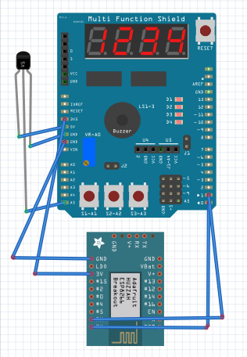

1. **SCREENSHOTS OF EACH TASK OUTPUT (ATMEL STUDIO OUTPUT)**

Atmel Studio Data Visualizer Output:

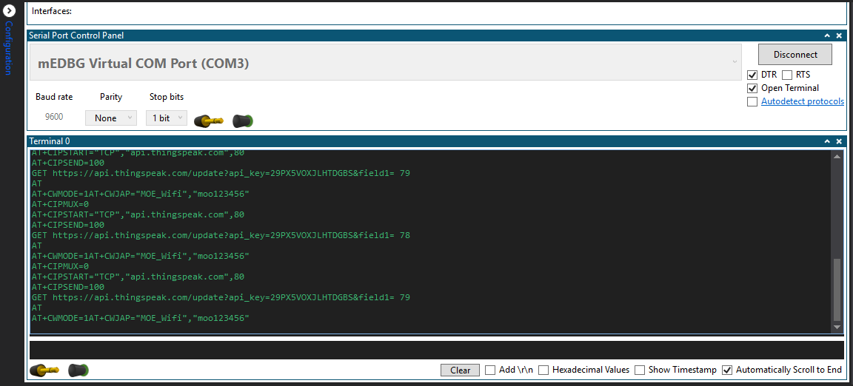

Thingspeak chart:

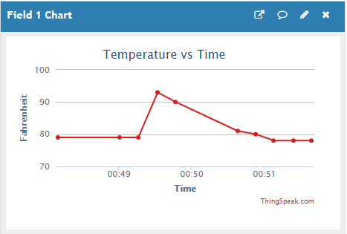

1. **SCREENSHOT OF EACH DEMO (BOARD SETUP)**

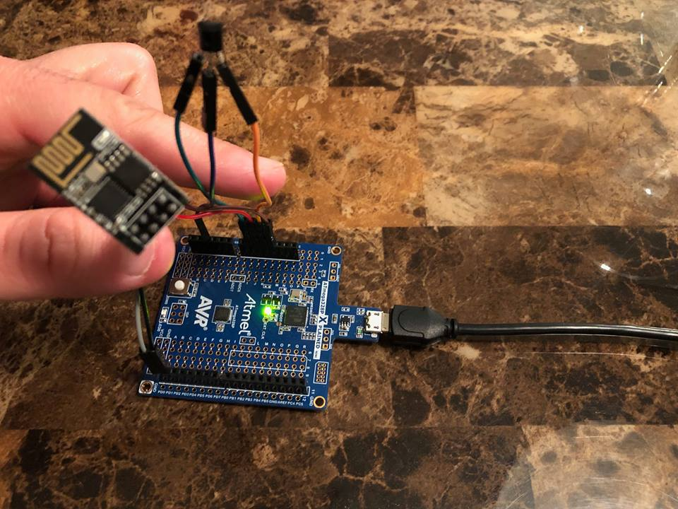

1. **VIDEO LINKS OF EACH DEMO**

LINK: <https://www.youtube.com/watch?v=JwtS438Qlk4&feature=share&fbclid=IwAR374_PRDzPb-PNv2InoKXLFQCUi2diZnEY9gIvx-M40eNJOKoSkCbDw5YY>

1. **GITHUB LINK OF THIS DA**

LINK: https://github.com/MohamedJundi1994/Submission_Midterm1.git

“This assignment submission is my own, original work”.

MOHAMAD JUNDI